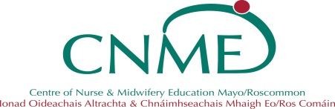

Centre of Nursing & Midwifery Education

St. Mary’s Campus

Castlebar, Co. Mayo

Phone: 094-9042054,2122,2055,2067,2184,2074

## Learning Event Application Form / Conference Application Form 1 *please complete all appropriate sections, incomplete forms will be returned. This information will be recorded on a database*

|  |  |  |  |  |  |
| --- | --- | --- | --- | --- | --- |
| To be completed by Applicant | | | | | |
| Your home address, mobile number & email are requested to enable us to manage all matters relating to this application form. Signature of this form indicates your consent to your contact details in relation to this programme. This information will be recorded on a database. | | | | | |
| Name: | | | Job Title: | | |
| Work Location & Address: | | | | | |
| Home Address: | | | | | |
| Mobile No: | Personnel No: | | | NMBI PIN No: | |
|  | | | | | |
| Email: | | | Date of Event: | | |
| Event Title: | | | | | |
| Venue: | | | Cost of Event *(if applicable): Attach outline & costing of conference* | | |
| Please indicate why you wish to apply for this event? | | | | | |
| Signature of Applicant: | | | | Date: | |
| To be completed by Line Manager / ADoNM / DoNM | | | | | |
| State reasons for supporting this application: | | | | | |
| Study Leave Approved (if applicable) | | | | | Hours: |
| Line Manager Signature: | | | | | Date: |
| DoN/ADoNM Signature: | | | | | Date: |
| Email: | | Work address: | | | |

**For Office Use Only: Centre of Nursing & Midwifery Education**

|  |  |  |
| --- | --- | --- |
| Conference fee approved: YES / NO **€** | Signed: | Date: |

# **If approved by CNME, Conference fee will be refunded once verification of attendance is submitted along with the receipt of payment to the CNME. Claims for reimbursement must be submitted within eight weeks of attending the Conference