Form 1: Expression of Interest for ONMSD/NMPDU Support for

E-Learning/On Line Initiative
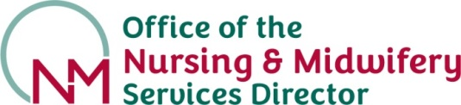

This application process for funding support for e-Learning programmes or online initiatives consists of 2 parts.

Form 1: Expression of Interest to ONMSD/NMPDU.
Form 2: If ONMSD/NMPDU agree to progress your Form 1 Expression of Interest application, a more detailed review of requirements and a submission of costing (based on consultation with HSeLanD) will be requested in Form 2.

Name of Applicant:
NMBI PIN: |  |  | Email: | Tel No:
Name of Service:
Subject area of e-Learning programme/initiative:
Is the programme/initiative part of a national learning initiative/National Clinical Programme or is it targeted at a local audience?
Please note that priority will be given to programmes of national relevance by NMPDU/ONMSD.
Describe the nature and overall purpose of the proposed e-Learning programme/initiative:
Why is this e-Learning programme/initiative needed?
Who is the Target Audience?
Approximately how many learners will access the programme per annum?
Proposed Start Date:
Line Manager Form 1 Submission
Name of applying DoN/DoM/Dir CNME/Service Manager:
Date of submission:
Programme Sponsor Support
The programme sponsor is responsible for funding the project. The sponsor is accountable for ensuring that the work is governed effectively and delivers the objectives that meet identified needs.

By signing below you are agreeing to undertake a programme review when contacted by the HSeLanD Governance Group. If authorised, this programme is required to have a total review 2 years from when it was posted on HSeLanD.

Programme Sponsor
Name: Signature: ___________________________

Date: _____________
Please forward the completed form to ONMSD/your local Director NMPDU

