FAQ guide for staff:

How to Develop HSE National Policies, Procedures, Protocols

and Guidelines

A Practical Guide 2023

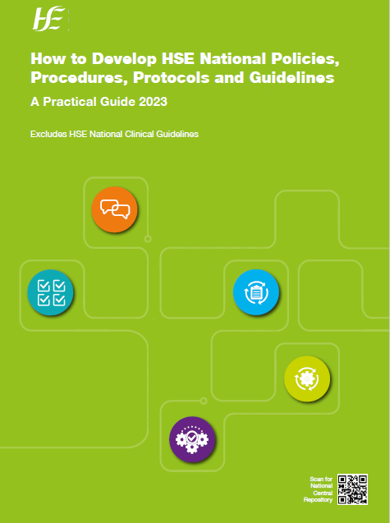

How to Develop HSE National Policies, Procedures, Protocols and Guidelines

A Practical Guide 2023

Q1: | Does this guide replace the 2016 Framework for Developing PPPGs?
A: | Yes. The Practical Guide will be effective from 05/12/2023 and the framework will be stood down.
Q2: | What are National 3PGs?
A: | They are policies, procedures, protocols or guidelines developed at a national level to support local implementation groups in establishing consistency in all services across the country.
Q3: | What is included in scope of the guide?
A: | This guide applies to all HSE and HSE-funded services and covers all documents on any topic that is defined as a national policy, procedure, protocol or guideline.
Q4: | Are HSE National Clinical Guidelines included in the scope?
A: | No. HSE National Clinical Guidelines are excluded from scope of this guide.
Q5: | Who will use this Practical Guide?
A: | The guide is for all staff involved at any stage of National 3PG development across our health service.
Q6: | How is the new guide laid out?
A: | The core guide has two sections.  - Section 1 is about the five key stages of National 3PG development.  - Section 2 is about reviewing and updating a National 3PG.  Each section is set out as follows:  - Toolkit  - Short introduction  - key steps and activities  - Tops tips
Q7: | What are the Toolkits for?
A: | The Toolkits are suggested links to resources that may help you progress your document.
Q8: | What are the stages of National 3PG development?
A: | The development of National 3PGs is a five stage approach, outlined as:  deciding the need – planning – development – implementation - sustainability
Q9: | What is deciding the need stage?
A: | - It is important to first decide if there is a need for any particular National 3PG.  - All National Functions and teams across our health service must have a clear governance structure that prioritises National 3PGs being considered for development.  - The topic being considered for development must be aligned with the right priority factors.  - Multiple sources of information should be considered to decide if you should develop a National 3PG or not.
Q10: | What is the planning stage?
A: | - Before any development is started on the document, good governance must be put in place such as identifying the Document Owner, Document Approver, Governance Group and Chair of Development Group.  - This stage also includes establishing membership, identifying stakeholders, agreeing the type of document to develop, the scope, developing the terms of reference and declaring and managing any conflicts of interest.
Q11: | What is the development stage?
A: | - HSE National 3PGs must be evidence based, so this stage includes gathering and evaluating the best available evidence. This can be supported by linking in with a librarian for literature reviews.  - This stage also includes developing your guidance, recommendations, tools and resources, consultation and expert reviews, and approval.
Q12: | What is the implementation stage?
A: | This stage is about how to change current practice to the guidance and recommendations in the new or updated National 3PG.
Q13: | What is the sustainability stage?
A: | Sustainability activities are essential to make sure the guidance and recommendations in the National 3PG are fully put in place at local service delivery areas.
Q14: | Will we need to adapt our National 3PG training programme
A: | Staff will need to do a gap analysis of their education programme against the Practical Guide and what guidance/template/tools are on the HSE National Central Repository, and identify their action plan for compliance.

The HSE National Central Repository
Important Q&A for all HSE National 3Gs and all HSE National Clinical Guidelines
Q1: | Is it mandatory to use the National Template when developing HSE national policies, procedures, protocols, guidelines (3PGs) and clinical guidelines?
A: | Yes use of the National Template is mandatory, no exceptions after 29/03/2024. All new documents and those due for revision should develop their document on the National Template, which is accessible on the HSE National Central Repository.
Q2: | Why has the National Template got a new cover page?
A: | The new cover pages (2+3) of the National Template was developed in order to meet the document management requirements of the HSE National Central Repository.
Q3: | Do all HSE National 3PGs and HSE National Clinical Guidelines need to be published on the HSE National Central Repository only?
A: | Yes, all HSE National 3PGs and HSE National Clinical Guidelines must only be published on the HSE National Central Repository.  For assistance contact the team at ncr.team@hse.ie

