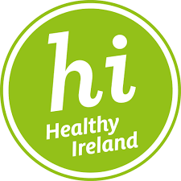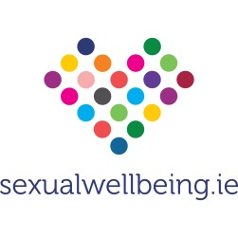

Foundation Programme in Sexual Health Promotion
The new revised format 6-day FPSHP is a comprehensive capacity building training programme for service providers who want to develop their confidence, skills and knowledge in the area of sexual health promotion, and incorporate sexual health promotion into their work.

Who is the programme for?
The FPSHP is for service providers from the health, education, community and youth sectors who have the potential and capacity to undertake Sexual Health Promotion within their organisation.
Is the course certified?
The FPSHP is certified by HSE Health Promotion & Improvement and endorsed by:
• The Nursing and Midwifery Board of Ireland Category 1(35 CEUs)
• Irish Association Social Workers Accredited
• Irish Association Counselling and Psychotherapy 60 hours attended

What is the benefit to participants and their organisations?
Participants will:
- Have the opportunity to improve their knowledge, skills and confidence in relation to sexual health work in their organisation.
- Have access to a Sexual Health Resource Library to support their work in Sexual Health Promotion in their organisation on completion of the programme.
- Receive ongoing updates/newsletters relating to Sexual Health.
- Be notified of further related training events. Programme Content This programme takes a holistic, life-course approach to sexual health promotion.

The course content includes:
- Sexual Health Promotion in the Irish Context
- A Life-Course Approach to Sexual and Reproductive Health
- Gender Roles and Stereotypes • Self Esteem and Sexual Health
- Sex, Society and Culture (including Diversity and Discrimination)
- Sexual Pleasure within Sexual Health Promotion
- Irish Law and Sexual Health (including Power and Control Healthy and Unhealthy Relationships)
- Working safely around Sexual Health (Transferring skills to practice )

Methodology
The programme is delivered by Olivia McGeough and David McSweeney Health Promotion & Improvement Officers, CHO8.
The programme utilises participatory and experiential methodologies.
The focus is on providing opportunities for group work, open discussion and the exploration of participants’ personal attitudes and values in relation to sexual health.

Cost
The programme fee is covered by HSE Health Promotion and Improvement, Health and Wellbeing Division.

Dates & Location
September 7th & 8th October 20th & 21st November 16th &17th
REC,St. Brigid’s Complex, Kells Rd, Ardee, Co Louth.
Attendance at all six days is compulsory for certification.

How to apply?
Application is a 2-step process comprising an application form and telephone interview
Application forms must be signed by a line manager to confirm approval to attend the all six days of the programme.
The closing date for receipt of applications is Friday 17th June, 2022.

Application forms are available on request from geralyn.nolan@hse.ie / 041 6850675

