Health Service Provider Name:____________________________________

Nurse and Midwife Medicinal Product Prescribing

Sample Addendum
 | Version: X
Owner: | Addendum Authors:
Approved By: | Pages:  1 of..
Effective from: XXXXX | Review Date: XXXXX

Document Approval

____________________________
Director of Nursing /Midwifery/Services Manager

Date: ________________

________________________
Other signatures as per local Health Service Provider

Date:___________________

These are examples of some headings that may/may not be included in a local addendum, other headings can be included as per local health service provider requirements.

Each heading can be populated as per the local health service provider requirements.

Sample Addendum:

- Purpose of Addendum

- Scope of Addendum

- Scope of Prescribing Practice for RNMPs (i.e. working within scope of practice with or without the requirement for a list of medicines as per local health service provider Policy, Procedure, Protocol, Guideline (PPPG))

- Record of Prescribing Activity by RNMPs to Enable Audit

- Audit of RNMP Prescribing Practice i.e. Frequency of Audit

- Continuous Professional Development (CPD)

- Security and Safe Handling of Prescription Pads

Please refer to the Practice Standards and Guidelines for Nurses and Midwives with Prescriptive Authority (4th edition) (NMBI, 2019) for further information available at: https://www.nmbi.ie/NMBI/media/NMBI/NMBI-Practice-Standards-Guidelines-02-03-2020_2.pdf?ext=.pdf

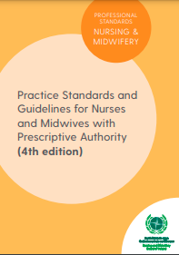

The addendum should be attached to a copy of the HSE National Nurse and Midwife Medicinal Product Prescribing Guideline (2020), if you are using this guideline available at: National Nurse and Midwife Medicinal Product Prescribing Guideline 2020 (hse.ie) or attached to the local health service provider PPPG for nurse and midwife medicinal product prescribing.

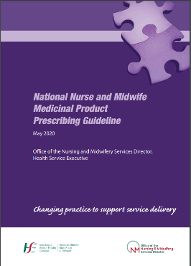

Further information and resources regarding nurse and midwife medicinal product prescribing is available at: https://healthservice.hse.ie/about-us/onmsd/onmsd/specific-programmes/nurse-midwife-medicinal-product-prescribing.html

